Mini Project Report

On

HANGMAN GAME

Submitted as partial fulfillment for the award of

BACHELOR OF TECHNOLOGY

DEGREE

Session 2021-22

In

Information Technology

By

Student Name

Roll No

Coordinated By: - Name of Project Coordinator

(Assistant Professor)

DEPARTMENT OF INFORMATION TECHNOLOGY

ABES ENGINEERING COLLEGE, GHAZIABAD

   AFFILIATED TO

DR. A.P.J. ABDUL KALAM TECHNICAL UNIVERSITY, U.P., LUCKNOW

(Formerly UPTU)

Student’s Declaration

I hereby declare that the work being presented in this report entitled “HANGMAN GAME” is an authentic record of my own work carried out under the supervision of Project Coordinator, Assistant Professor, Information Technology.

The matter embodied in this report has not been submitted by me for the award of any other degree.

Date:

Name: Student Name

**Roll No.: …………………….**

**Department: Information Technology**

This is to certify that the above statement made by the candidate(s) is correct to the best of my knowledge.

**Signature of HOD Signature of Coordinator**

**(Name: Prof. Amit Sinha) (Name: Mr. Jitendra Chauhan)**  
  
 **(Information Technology) (Assistant Professor)**

**(Information Technology)**

**Date: ………..**

**ACKNOWLEDGEMENT**

Presentation inspiration and motivation have always played a key role in the success of any venture.

I express my sincere thanks to my project coordinator **Dr. Harikesh Singh** to encourage me to the highest peak and to provide me thisopportunity to prepare this project. I extend my heartly thanks for giving me the proper guidance even in this time, when everything is continuing on just online platforms.

I am highly indebted to **Dr. Harikesh Singh** for the constant supervision, for providing all the necessary information and support in completing the project.

Finally, I am sincerely thankful to all those people who are directly or indirectly involved in the successful completion of this project work.

**Signature of student**

**Name: ……………….**

**Roll No: - …………………**

**TABLE OF CONTENTS**

|  |  |  |
| --- | --- | --- |
| **S. NO.** | **CONTENTS** | **PAGE** |
| i | Acknowledgement | 3 |
| ii | List of figures | 5 |
| iii | Abstract | 6 |
| 1 | Introduction | 7 |
| 2 | Python Programming Language | 8 |
| 3 | Project Objective | 9 |
| 4 | Project methodology | 10 |
| 5 | Problem Statement | 11 |
| 6 | Details of project work | 11-13 |
| 7 | Discussion and Result | 14 |
| 8 | Conclusion | 15 |
| 9 | Future Development | 16 |
| 10 | Reference | 17 |
| 11 | Appendix |  |
| i | Coding | 18-20 |
| ii | Output | 21-23 |

LIST OF FIGURES

|  |  |
| --- | --- |
| **FIGURE NO** | PAGE NO |
| **Figure 1** | **12** |
| **Figure 2** | **12** |
| **Figure 3** | **13** |

ABSTRACT

The **Hangman Game In Python** project requires good knowledge of Python which includes defining functions and managing for/while loops. The functions that we use here contain arguments that are defined in a global scope which can be further used in other functions to improve game quality. It can also be used to provide different steps when required to execute upon conditions by the for and while loops.

The objective of our project is to implement the hangman game using Python. It doesn’t require any specific modules other than random and time. Python loops and functions are enough to build this Game here.

I take help from my coordinator whenever I stuck, making project is always very interesting. In future I would like to add more levels in this game which will make it little difficult and more interesting.

**INTRODUCTION**

This is a simple **HANGMAN GAME** using a Python programming Language. We can use this as a Project to boost our programming Skills and understanding logic. The HANGMAN Program randomly Selects a secret word from a list of secret words.

The random Module will provide this ability, so line 1 in the program Imports it.

**‘HANGMAN’** is a popular word game in which one player

(“Chooser”) chooses a secret word and another player

(“The Guesser”) attempts to guess the word one letter at a time.

If a guessed letter appears in the word, all instances of it are

Revealed. If not, the guesser loses a chance. If the guesser

Figures out the secret word before he or she runs out of chances,

He or she wins. If not, the player who choose the word wins.

There will be exactly 6 chances of guessing a word. If the user

exceed all the 6 chances by guessing a wrong word, then the

game is over.

**ARSH SRIVASTAVA**

Python is one of the many open source object oriented programming application software

available in the market . Python is developed by Guido van Rossum. Guido van Rossum started

implementing Python in 1989. Python is a very simple programming language so even if you are

new to programming, you can learn python without facing any issues. Some of the many uses

of Python are application development, implementation of automation testing process, allows

multiple programming build, fully constructed programming library, can be used in all the major

operating systems and platforms, database system accessibility, simple and readable code, easy

to apply on complex software development processes, aids in test driven software application

development approach, machine learning/ data analytics, helps pattern recognitions, supported

in multiple tools, permitted by many of the provisioned frameworks, etc.

Python is one of the many open source object oriented programming application software

available in the market . Python is developed by Guido van Rossum. Guido van Rossum started

implementing Python in 1989. Python is a very simple programming language so even if you are

new to programming, you can learn python without facing any issues. Some of the many uses

of Python are application development, implementation of automation testing process, allows

multiple programming build, fully constructed programming library, can be used in all the major

operating systems and platforms, database system accessibility, simple and readable code, easy

to apply on complex software development processes, aids in test driven software application

development approach, machine learning/ data analytics, helps pattern recognitions, supported

in multiple tools, permitted by many of the provisioned frameworks, etc.

Python is one of the many open source object oriented programming application software

available in the market . Python is developed by Guido van Rossum. Guido van Rossum started

implementing Python in 1989. Python is a very simple programming language so even if you are

new to programming, you can learn python without facing any issues. Some of the many uses

of Python are application development, implementation of automation testing process, allows

multiple programming build, fully constructed programming library, can be used in all the major

operating systems and platforms, database system accessibility, simple and readable code, easy

to apply on complex software development processes, aids in test driven software application

development approach, machine learning/ data analytics, helps pattern recognitions, supported

in multiple tools, permitted by many of the provisioned frameworks, etc

**Python Programming Language**

Python is one of the many open source object oriented programming application software available in the market .Python is developed by

Guido van Rossum.

Guido van Rossum started implementing Python in 1989. Python is a very simple programming language so even if you are new to programming, you can learn python without facing any issues.

Some of the many uses of Python are application development, implementation of automation testing process, allows multiple programming build, fully constructed programming library, can be used in all the major operating systems and platforms, database system accessibility, simple and readable code, easy to apply on complex software development processes, aids in test driven software application development approach, machine

learning/ data analytics, helps pattern recognitions, supported in multiple tools, permitted by many of the provisioned frameworks, etc.

**PROJECT OBJECTIVE**

This is an old game that sadly has a rather unpleasant name (and matching graphic). Another name for the game is “Gallows”, which is also of questionable taste . . . This game often is used for learning the vocabulary of a language. If you don’t know the game, play a game or two on http://www.manythings.org/hmf/8997.html. Next, check out the demo video, available on the course website, of our “Hangman” game. the version of “Hangman” uses words chosen from a list of commonly used English words. A round of the game begins with a randomly chosen word (hidden from the player except for the length). The player keeps guessing until seven wrong guesses have been made or until the word is completed, whichever happens first. At the end of a round, the user is prompted to indicate whether he/she wants to play again. The game ends when the player indicates that he/she wants to quit. You will build this program in a modular fashion by writing four functions: • hangman: the main function that starts the game, handles user interaction, and creates and updates the figure. This function calls the remaining three functions. • get Words: read the data file and return the words in a cell array • new Word: randomly select a word that hasn’t been used before from the cell array • find Letter In Word: locate a letter in a word You may write subfunctions as appropriate. You can use the general built-in functions that we have used in the past such as length, rand, plot, . . . , etc., but only the following file and string handling functions are allowed: fopen, fclose, fe of, fgetl, char, str2double, strcmp, lower, upper, is letter. Additionally, there are two general built-in functions introduced in Insight that you may want to use: all and any.

**PROJECT METHODOLOGY**

"The origins of Hangman are obscure meaning not discovered, but it seems to have arisen in Victorian times ," says[Tony Augarde,](https://en.wikipedia.org/w/index.php?title=Tony_Augarde&action=edit&redlink=1) author of *The Oxford Guide to Word Games*

. The game is mentioned in[Alice](https://en.wikipedia.org/wiki/Alice_Gomme) [Bertha Gomme'](https://en.wikipedia.org/wiki/Alice_Gomme)s "Traditional Games" in 1894 under the name "Birds, Beasts and Fishes." The rules are simple; a player writes down the first and last letters of a word and another player guesses the letters in between. In other sources, the game is called "Gallows", "The Game of Hang in'", or "Hanger". Primitively Hangman was a[paper and pencil guessing game](https://en.wikipedia.org/wiki/Paper_and_pencil_game)for two ( or more players) where one player thinks of a [word,](https://en.wikipedia.org/wiki/Word)[phrase](https://en.wikipedia.org/wiki/Phrase)or [sentence](https://en.wikipedia.org/wiki/Sentence_%28linguistics%29)and the other tries to guess it by suggesting[letters](https://en.wikipedia.org/wiki/Letter_%28alphabet%29)or [numbers,](https://en.wikipedia.org/wiki/Number) within a certain number of guesses. The word to guess is represented by a row of [dashes,](https://en.wikipedia.org/wiki/Dash_%28punctuation%29) representing each letter of the word. In most variants,[proper nouns,](https://en.wikipedia.org/wiki/Proper_noun) such as names, places, and brands, are not allowed. If the guessing player suggests a letter which occurs in the word, the other player writes it in all its correct positions. If the suggested letter or number does not occur in the word, the other player draws one element of a hanged man [stick figure](https://en.wikipedia.org/wiki/Stick_figure)as a[tally mark .](https://en.wikipedia.org/wiki/Tally_marks) Fig1- Primitive style of playing. (

*The underlined letters appear in the word in their correct places, while the crossed-out letters do not appear, and each crossed-out letter corresponds to one part of the drawing. In this case, the secret word is "hangman"..)*

PROBLEM STATEMENT

In today’s life, the stress is most dangerous disease, we cannot say it is just a disease it create a severe problem in life, which create a depression and lead to take a wrong steps in life.

To get away from this type of problem people should take break in between their busy schedule and have to play indoor and outdoor games. Just like that I have tried my best to make The Hangman Game to get relax in between the busy schedule.

**DETAILS OF PROJECT WORK**

*When the user plays Hangman, the computer first selects a secret word at random from a list built into the program. The program then prints out a row of dashes—one for each letter in the secret word—and asks the user to guess a letter. If the user guesses a letter that is in the word, the word is redisplayed with all instances of that letter shown in the correct positions, along with any letters correctly guessed on previous turns. If the letter does not appear in the word, the user is charged with an incorrect guess. The user keeps guessing letters until either (1) the user has correctly guessed all the letters in the word or (2) the user has made eight incorrect guesses. Two sample runs that illustrate the play of the game are shown in Figure 1 on the next page.*

*When it is played by children, the real fascination (a somewhat morbid fascination, I suppose) from Hangman comes from the fact that incorrect guesses are recorded by drawing an evolving picture of the user being hanged at a scaffold. For each incorrect guess, a new part of a stick-figure body—first the head, then the body, then each arm, each leg, and finally each foot—is added to the scaffold until the hanging is complete. For example, the three diagrams below show the drawing after the first incorrect guess (just the head), the third (the head, body, and left arm), and the diagram at the tragic end of a losing game:*

**Figure 1**

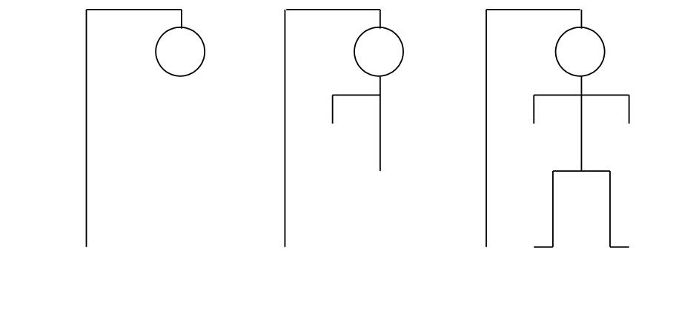

**Figure 2**

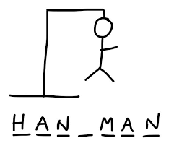

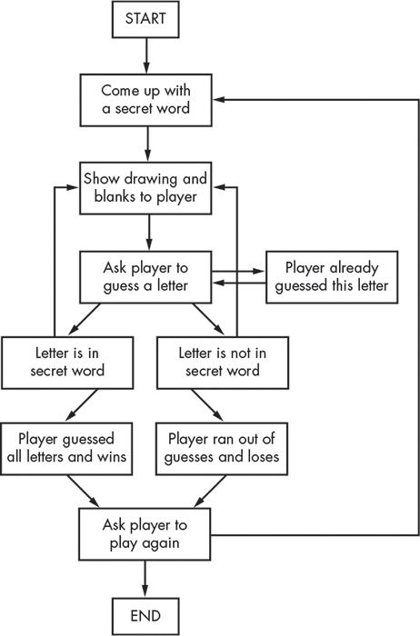

**Figure 3**

**RESULT & DISCUSSION**

* **This game is good for stress release.**
* **This Help in improving concentration.**
* **It is just a fun game, I used to play whenever I am free.**
* **This game also improve thinking power which is good for brain growth.**
* **At the end, I got good result after facing many problems.**
* **This game also help me improve and learn Python language.**

**CONCLUSION & FUTURE DEVELOPMENT**

**CONCLUSION**

In the conclusion of this project, Hangman is a traditional game, typically played with words. It’s possible, however, to play Category Hangman rather than guessing words the player might guess names of cities, or athletes, or fictional characters, or Duke professors, or top forty song titles the list is endless. You’ll be writing a program to play a “guess a word letter-by-letter” version of hangman as shown above. You’ll also be doing some statistical analysis of the words used in the Hangman game.

FUTURE DEVELOPMENT

* I would like to add levels in this game in future.
* I will also try to add timer so that it will little fast and more interesting.
* I will also try to add more functionality so that more player can play at a time.

**REFERENCES**

* **www.google.com**
* **www.wikipedia.com**
* [**www.itsourcecode.com**](http://www.itsourcecode.com)
* https://www.academia.edu/40383313

**APPENDIX 1:**

**CODING**

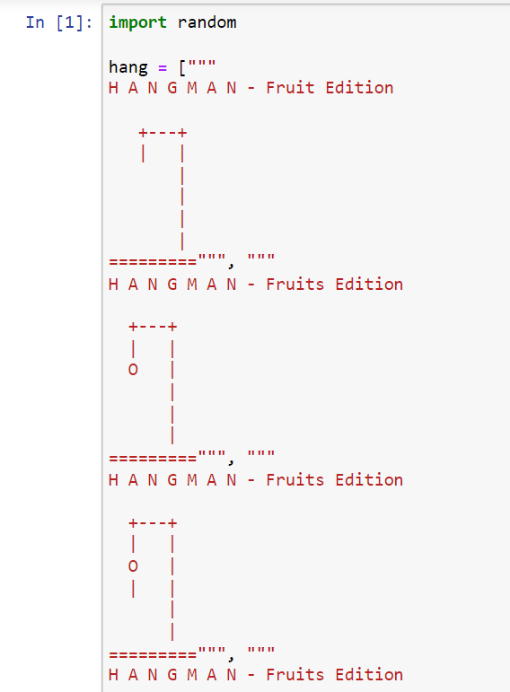

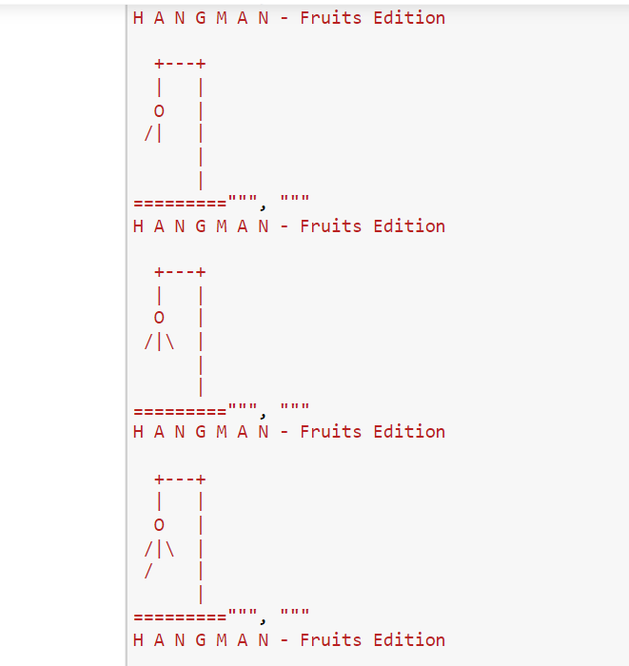

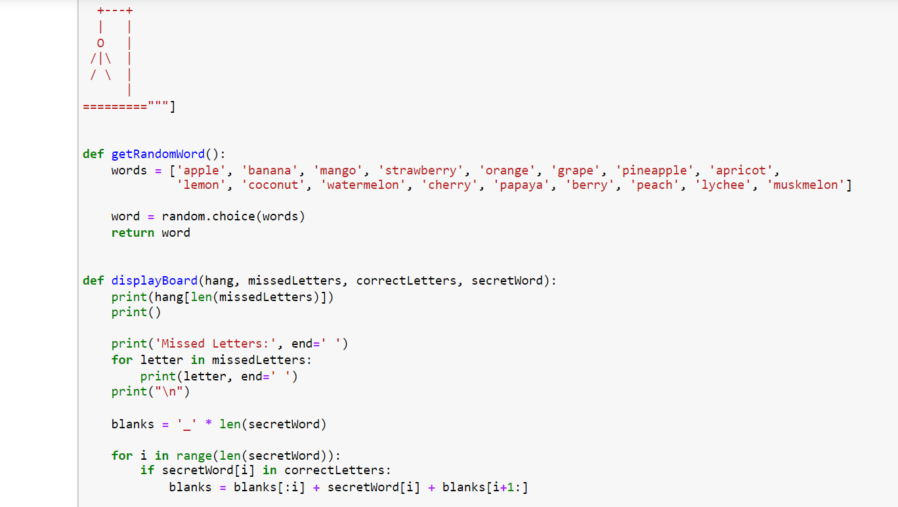

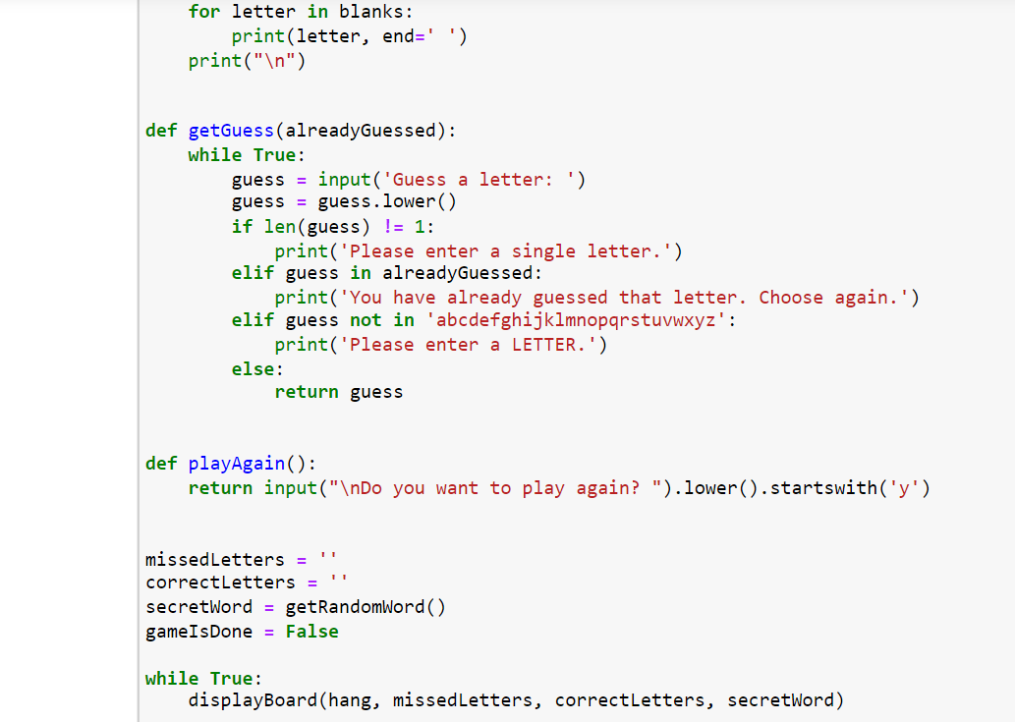

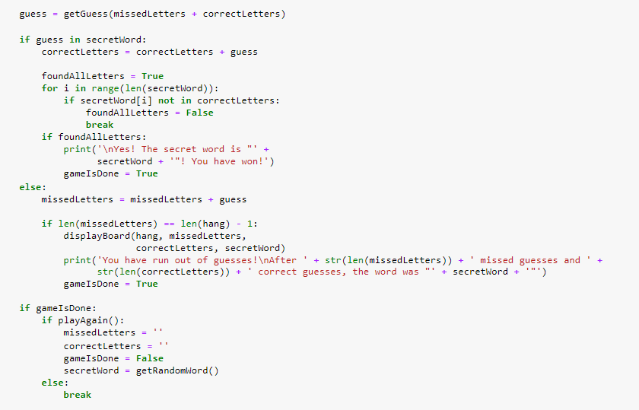

OUTPUT:

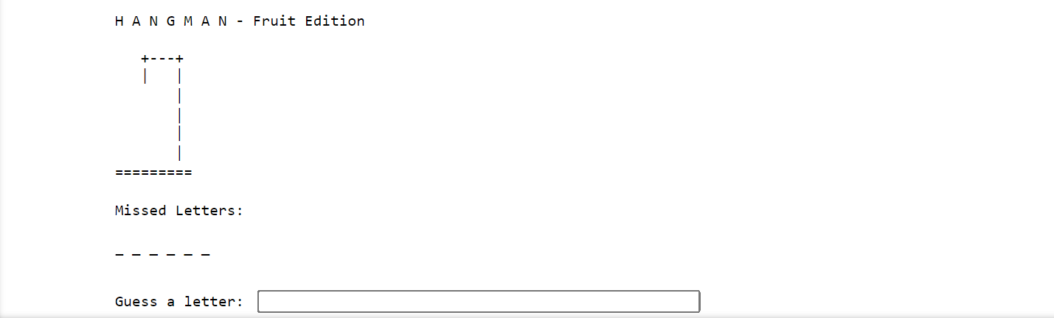

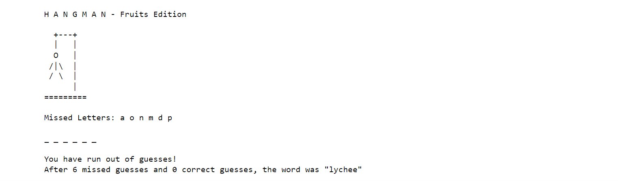

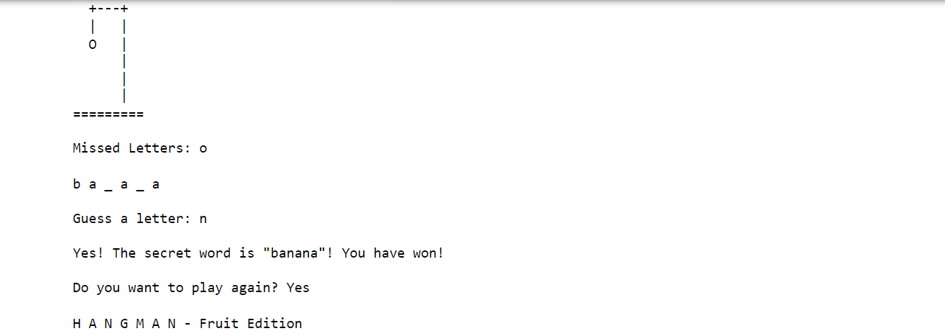

**THANK YOU!**